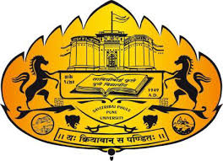
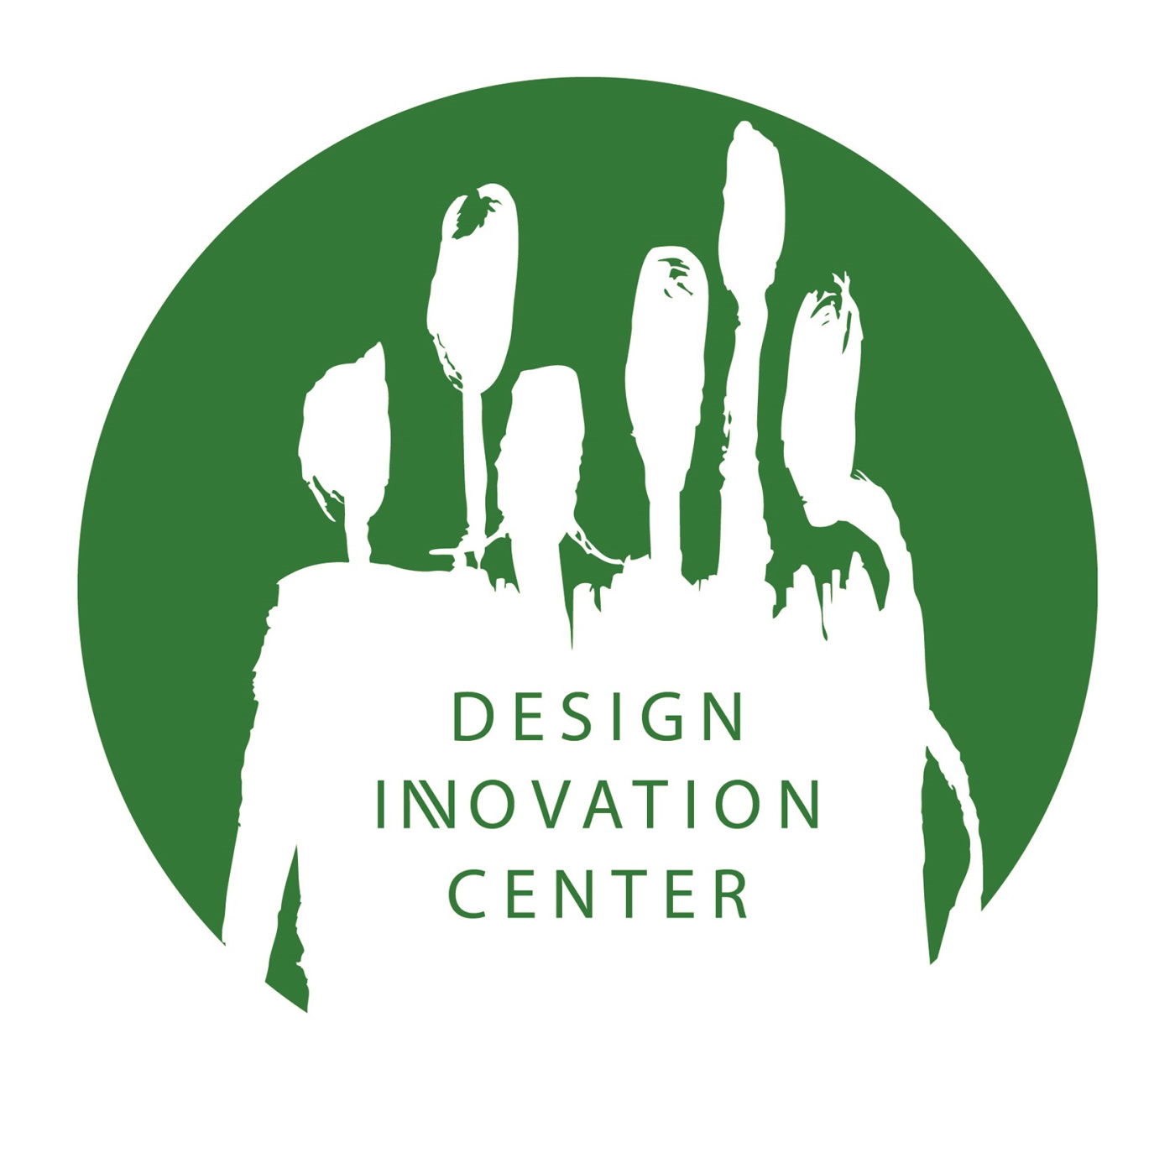

DESIGN INNOVATION CENTRE,
SAVITRIBAI PHULE PUNE UNIVERSITY, PUNE- 411007

STATUS OF PRODUCTS DEVELOPED BY DIC-SPPU TO FIGHT AGAINST COVID-19
S. No. | DICs | Product Image | Product/ Project | Current Stage/ Status | Next Step | Road Map
1. | DIC-SPPU  Spoke: Vigyan Ashram, Pabal | 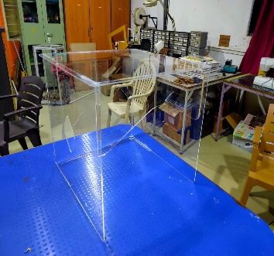 | Aerosol Box  https://www.facebook.com/vigyan.ashram.pabal/photos/a.916386231767331/3784010095004916/?type=3&theater | The product manufactured using open source design and Fab Lab facility and delivered to Noble Hospital Pune. | To manufacture aerosol box as per requirement from healthcare practitioners | It is only service against requirement.
2. | DIC-SPPU  Spoke: Vigyan Ashram, Pabal | 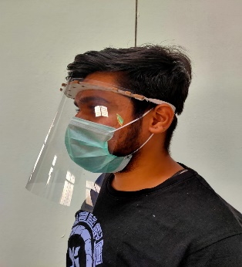 | Face shield  https://www.facebook.com/vigyan.ashram.pabal/posts/3766426960096563 | It is manufactured using open source design. So far 2400 shields were made and distributed to doctors and health workers | Plan to manufacture and distribute 5000 more face shields. | To manufacture 300 face shields daily
3. | DIC-SPPU  Spoke: Vigyan Ashram, Pabal |  | Disinfecting chamber  https://www.facebook.com/vigyan.ashram.pabal/posts/3777042185701707 | First prototype is developed, tested and installed at Vigyan Ashram Campus.  A DIY – Open Source Manual is published | To manufacture the product as per requirement | Discussing with Startups to take up manufacturing of the same.
4. | DIC-SPPU  Spoke: MVP College of Architecture & Design, Nashik | 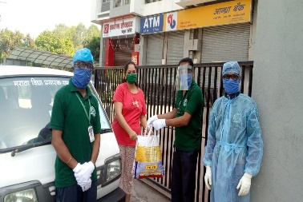 | MVP Krushi Basket | App Design and execution implemented | Reaching out and getting 100 more farmers connected. | Depending on the lockdown and COVID-19 status, planning to include other essentials into it like grocery. Initial homework is in process.
5. | DIC-SPPU  Spoke: MVP College of Architecture & Design, Nashik | 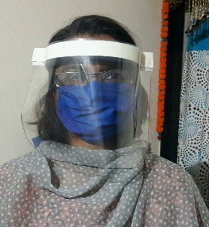 | Face Shield Mask | Face Shield mask handed over to Jan Shikshan Sansthan to empower self-help group women; 100 masks made out of which 50 provided to for Govt. PHCU and 50 to medical college | Material procured for 500 masks work in progress. | If needed as per the situation can expand production . Material search in process and linking to the self-help group in process.
6. | DIC-SPPU  Spoke: MVP College of Architecture & Design, Nashik |  | Auto Spray | Implemented Auto Spray of sodium hypo chloride tunnel at the gate of Dr. Vasantrao Pawar Medical college hospital and research center, Nashik. | Multiplication of the Sterilization tunnels | As per need we are ready to execute these tunnels. Material availability and work force for the task is good.

